**Year 11 Essentials**

**Practical Application – Collaborative**

**2 lessons in-class**

James moved out of his parents’ house at 24 years old, with $12,500 in his bank account. He works two jobs so he has money left over after he pays for his rent, bills, car repayment, and groceries. He lives in a shared house with 2 other adults. James pays $150 a week on rent, $50 more a week than the others because he sleeps in the master bedroom. Their weekly rent is $350 for a 3-bedroom, 2-bathroom house.

James’ first job is a car salesman at Car Giant. He works Monday – Thursday, 8 hours a day earning a salary of $35 000 a year, plus he receives 1% commission for each car he sells.

James’ also works as a barista for local coffee shop called Coffee Co., he usually works Friday – Sunday, earning $23.50 an hour.

**Part One:** Rent and Bills

James bought a car when he was 20 years old for $15, 000. He borrowed $10 000 from the bank at a rate of 2.3% simple interest for 5 years.

* If GST is included in the purchase price of his car, how much GST is included in the price?
* How much money does James have to pay the bank at the end of 5 years... if
$$Simple Interest=Principal ×\frac{Rate}{100} ×Time$$

* How much money is James spending a fortnight on his car repayments?
* James usually spends $250 a month on groceries, how much does he spend a week?
* If GST was included into the total bill, how much GST is James paying a week on groceries?
* James and his housemates split the water and electricity bill evenly. The water bill is usually around $225, which is paid 4 times a year. The electricity bill is usually around $375 which is paid 3 times a year. How much does James need to put away each month to pay for water and electricity?

**Part Two:** Occupation

* How much would James earn in March being a car salesman, if he sold 6 cars in the month. 3x cars for $21 000, 2x cars for $28 000 and 1x car for $15 000.
* How much money would James earn a week being a barista if he worked 8 hours on Friday (with a one-hour break), 5 hours on Saturday (with a half-hour break) and 5 hours on Sunday, (with time and a half pay, and a half an hour break)?
* Calculate his total fortnightly pay during the month of March, if he worked every Friday, Saturday and Sunday for the month at Coffee Co (same hours every week).

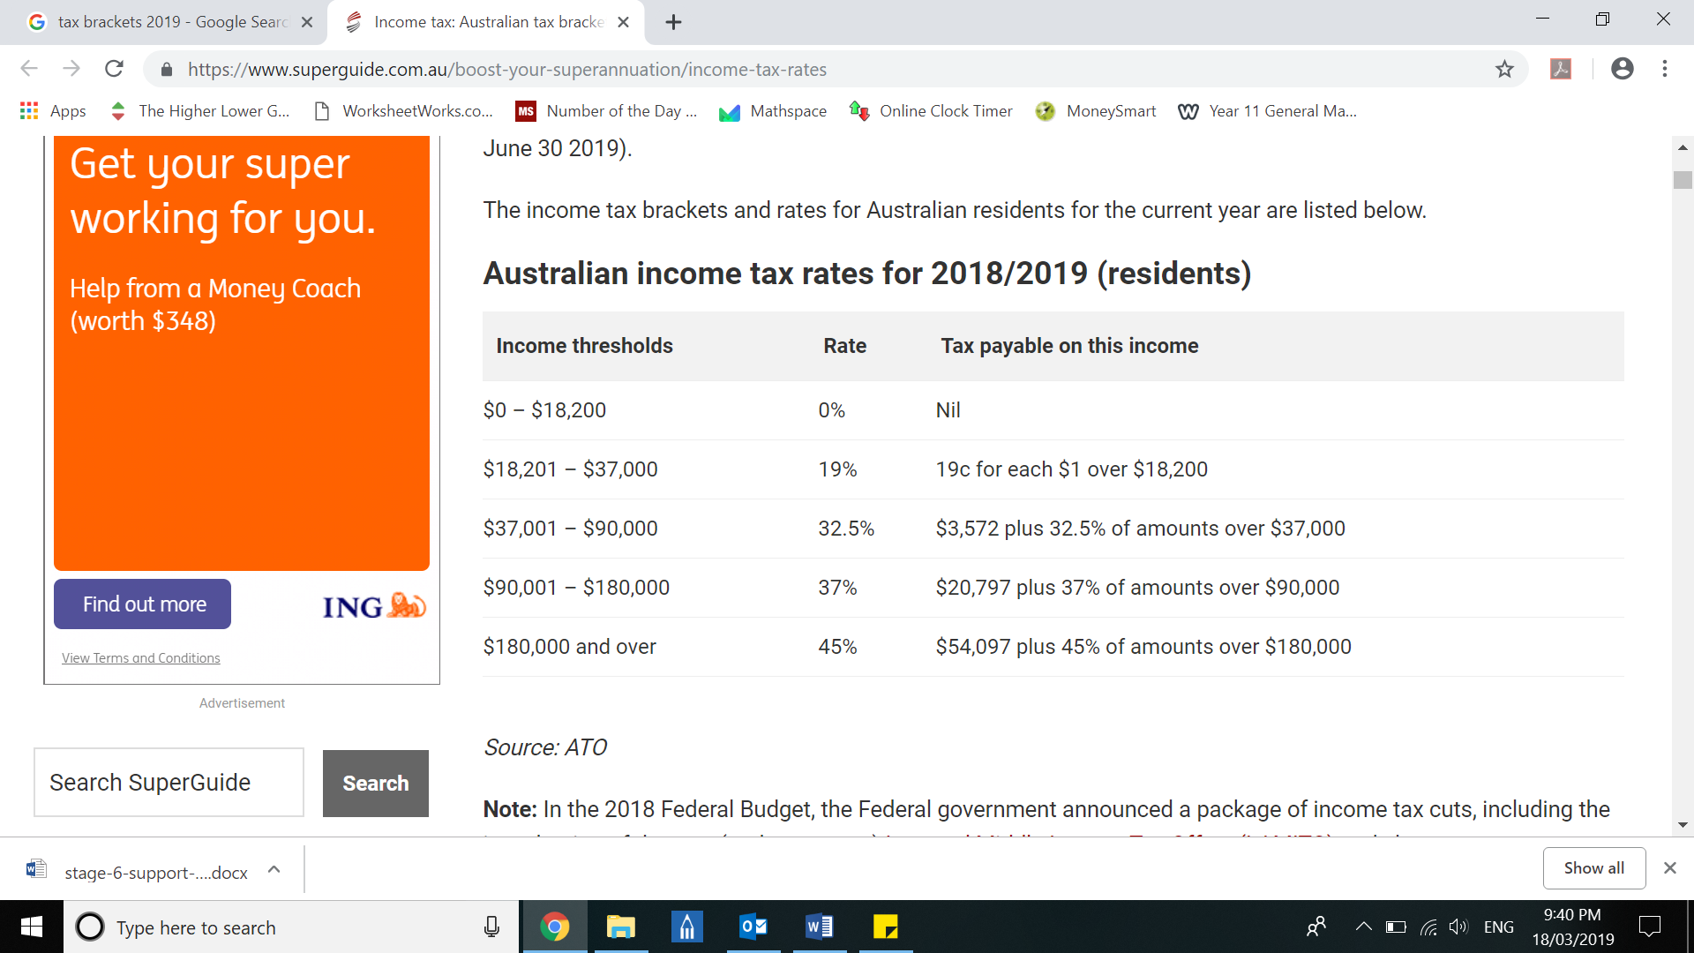**Part Three:** Tax and Superannuation

* If James’ Gross pay is $48 700 at Car Giant and $20 000 at Coffee Co. how much tax is he paying?
* It is a legal requirement that James’ employers also contribute an amount equal to 9.5% of his pay towards superannuation. What amount of superannuation is deposited each year?

**Part Four:** James lifestyle

* Calculate how much money, James has left in his bank account at the end of March. Don’t forget about his expenses.
* James needs $7000 in savings to so he can travel to America, how long will it take him to save that much money?